Affects of Domestic Violence on Children
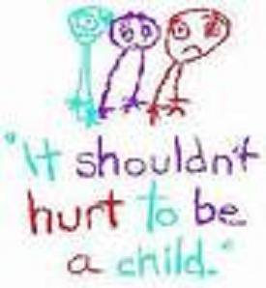

In homes where domestic violence occurs, children are at a higher risk of suffering physical abuse themselves. Regardless of whether children are physically abused, the emotional effects of witnessing domestic violence are very similar to the psychological trauma associated with being a victim of child abuse. Each year, an estimated minimum of 3.3 million children witness domestic violence. Listed below are some of the ways children can become affected:

Emotionally:
Guilt: feels the violence is his/her fault
Shame: having to keep family secrets
Fear/Anxiety: of violence or expressing feelings
Depressed/Powerless/helplessness: to change their home situation
Anger: about the violence or chaos
Grief: family losses, frequently moving
Burdened: with responsibility beyond their years, caretaking of parent(s) or other children

Physically:
Somatic complaints: headaches, stomachaches, asthma
Nervous/Anxious: short attention span, tired, lethargic, often sick
Decline in personal hygiene
Regression in developmental tasks: bed-wetting, thumb sucking, clinging, etc.
NO Reaction

Behaviorally:
Extremes in behavior: acting out or withdrawn, overachiever/underachiever
Sarcastic, ridged, defensive
Attention seeking behaviors
Bed-wetting, nightmares, chaotic behavior (trouble setting limits), running away

